<https://github.com/angel-vlzqz/Operating-Systems/tree/main/projects/project1> - github link

I have chosen features ls, cd, grep, whoami, and users.

When calling us, we can see a list of all programs, files, and folders in the current directory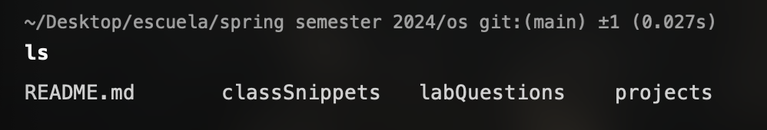

By calling an -F flag, we gain a bit more data and can see the directories as well.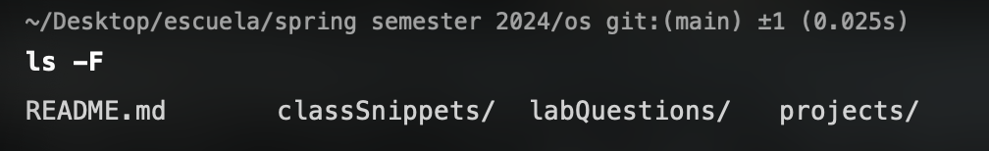

Regarding what happens behind the scenes, I believe the shell is checking all possibilities of what may be done with these files. If there is an action available, then it may be printed.

When calling cd by itself, the shell will direct us to the root directory of the system.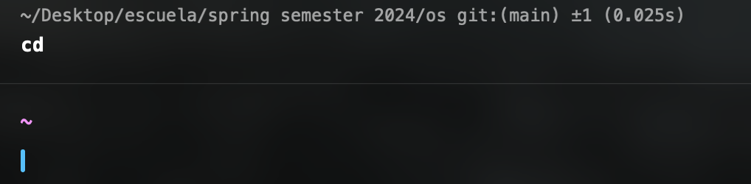

However, we can include a path after cd to take us wherever we want to.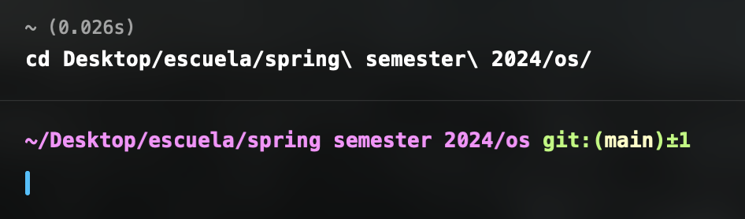

What is happening behind the scenes is the shell is accessing the file system and interpreting our cd input, sending the command through the file system, then navigates us to the location if the string was correct.

By using grep, I am able to search for a string a characters across a directory’s contents and find where those strings are repeated.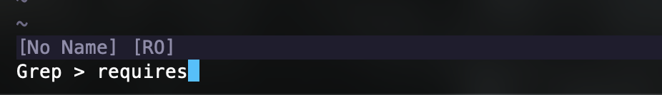

In this example, I can grep search the word requires in my vim config directory and find all the instances where the word “requires” is present. 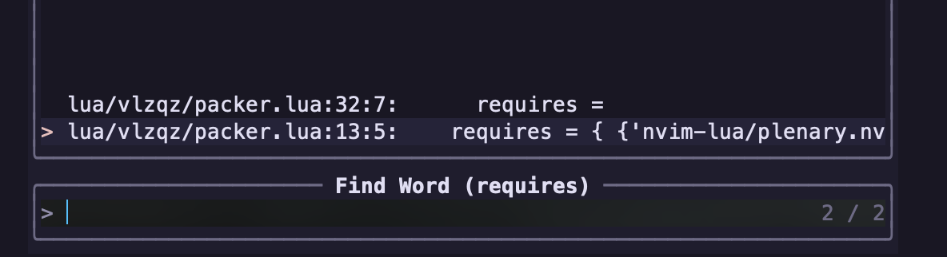

I only have the word “requires” in one file twice. I believe that Grep works by turning our input into a regular expression. Then, the shell checks every line in every file linearly to find an exact match.

When inputting whoami, the shell will return the system's current user.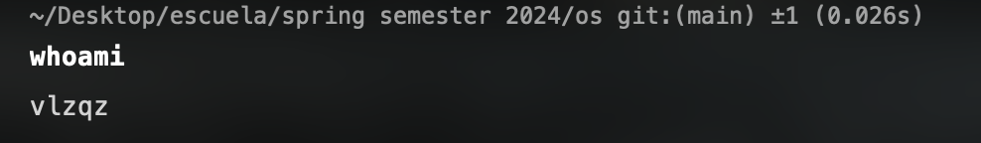

I believe that the shell is sending a command to the operating system to pull who is the current user of the machine.

When inputting users, the shell will return all of the users of the system.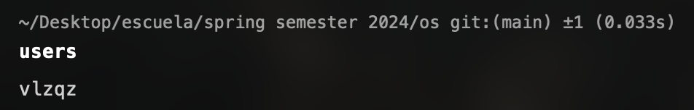

In this case, I am the only user of my system. I believe that the shell receives a list of users from the operating system and then proceeds to print it out onto the command line.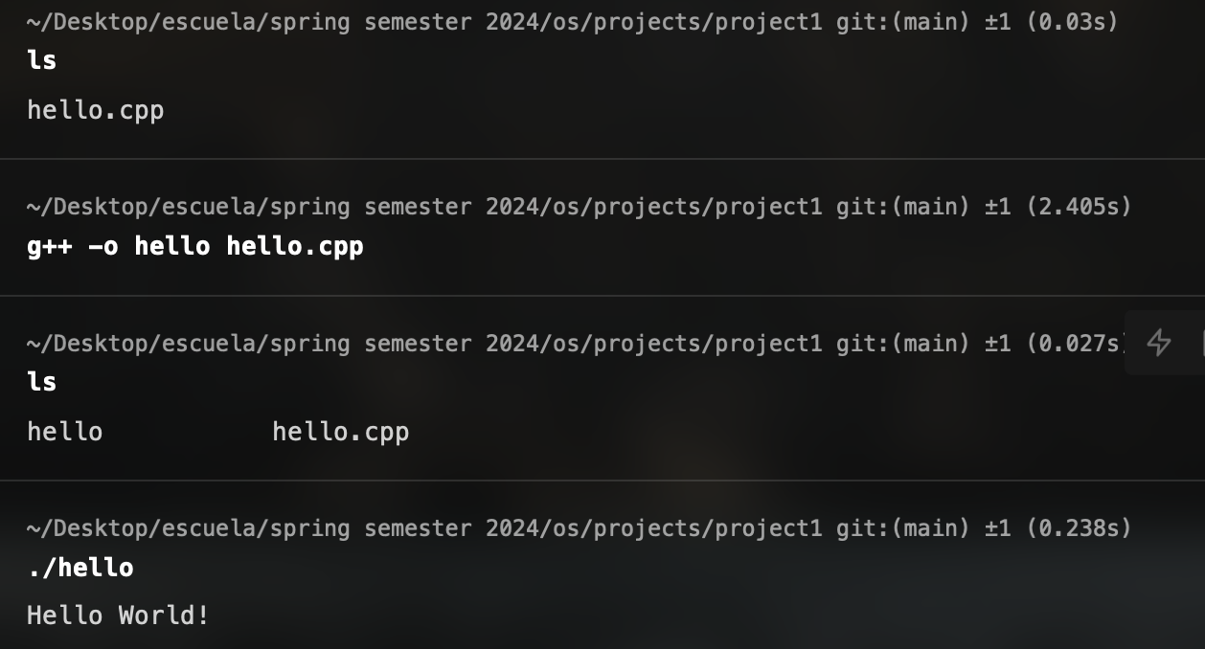

In the screenshot above. I list that I have a simple C++ program. I compile the program under the name “hello”, then run the program to show that it works.